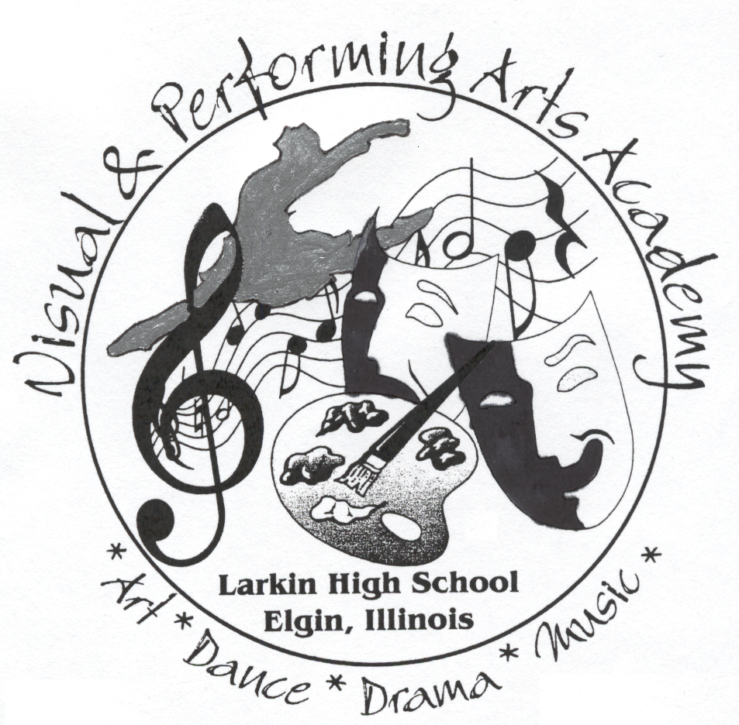
Larkin High School
Visual and Performing Arts Academy
1475 Larkin Avenue

Elgin, IL 60123-5198
847.888.5200, ext. 5201

STUDENT ESSAY FORM

(Please submit with online application)

____________________________________

Student Name Date

On the reverse side of this form, please write a one-page essay addressing the following questions. Please answer each question as completely as possible.

- Why would you like to attend this Academy?

- What career(s) are you currently interested in pursuing, and how do they relate to the Academy’s program?

- What are your talents and skills?

- Why do you think you would be an asset to the Academy program?

